MONGOLIAN ELECTIONS, 2017

Imagine, then, the scene. A vast open steppe in sweltering silence; a range of hills on the horizon, some topped with a few fir trees on their cooler northern slopes; a huge flock of sheep and goats, with a herdsman on his horse urging them on; a few gers (yurts) near a small river, each with its own solar panel outside and tv within; and a falcon circles overheard, in search of a marmot. In the middle of this quiet ocean of land stands a small one-roomed hut with a flag on top and a sign outside… for this is a polling station. It serves an area of over 1,000 sq. kms. and an electorate of about 1,200. The voters, some dressed in their very best, come by foot, by horse, by motorbike or by 4x4, all to have their say.

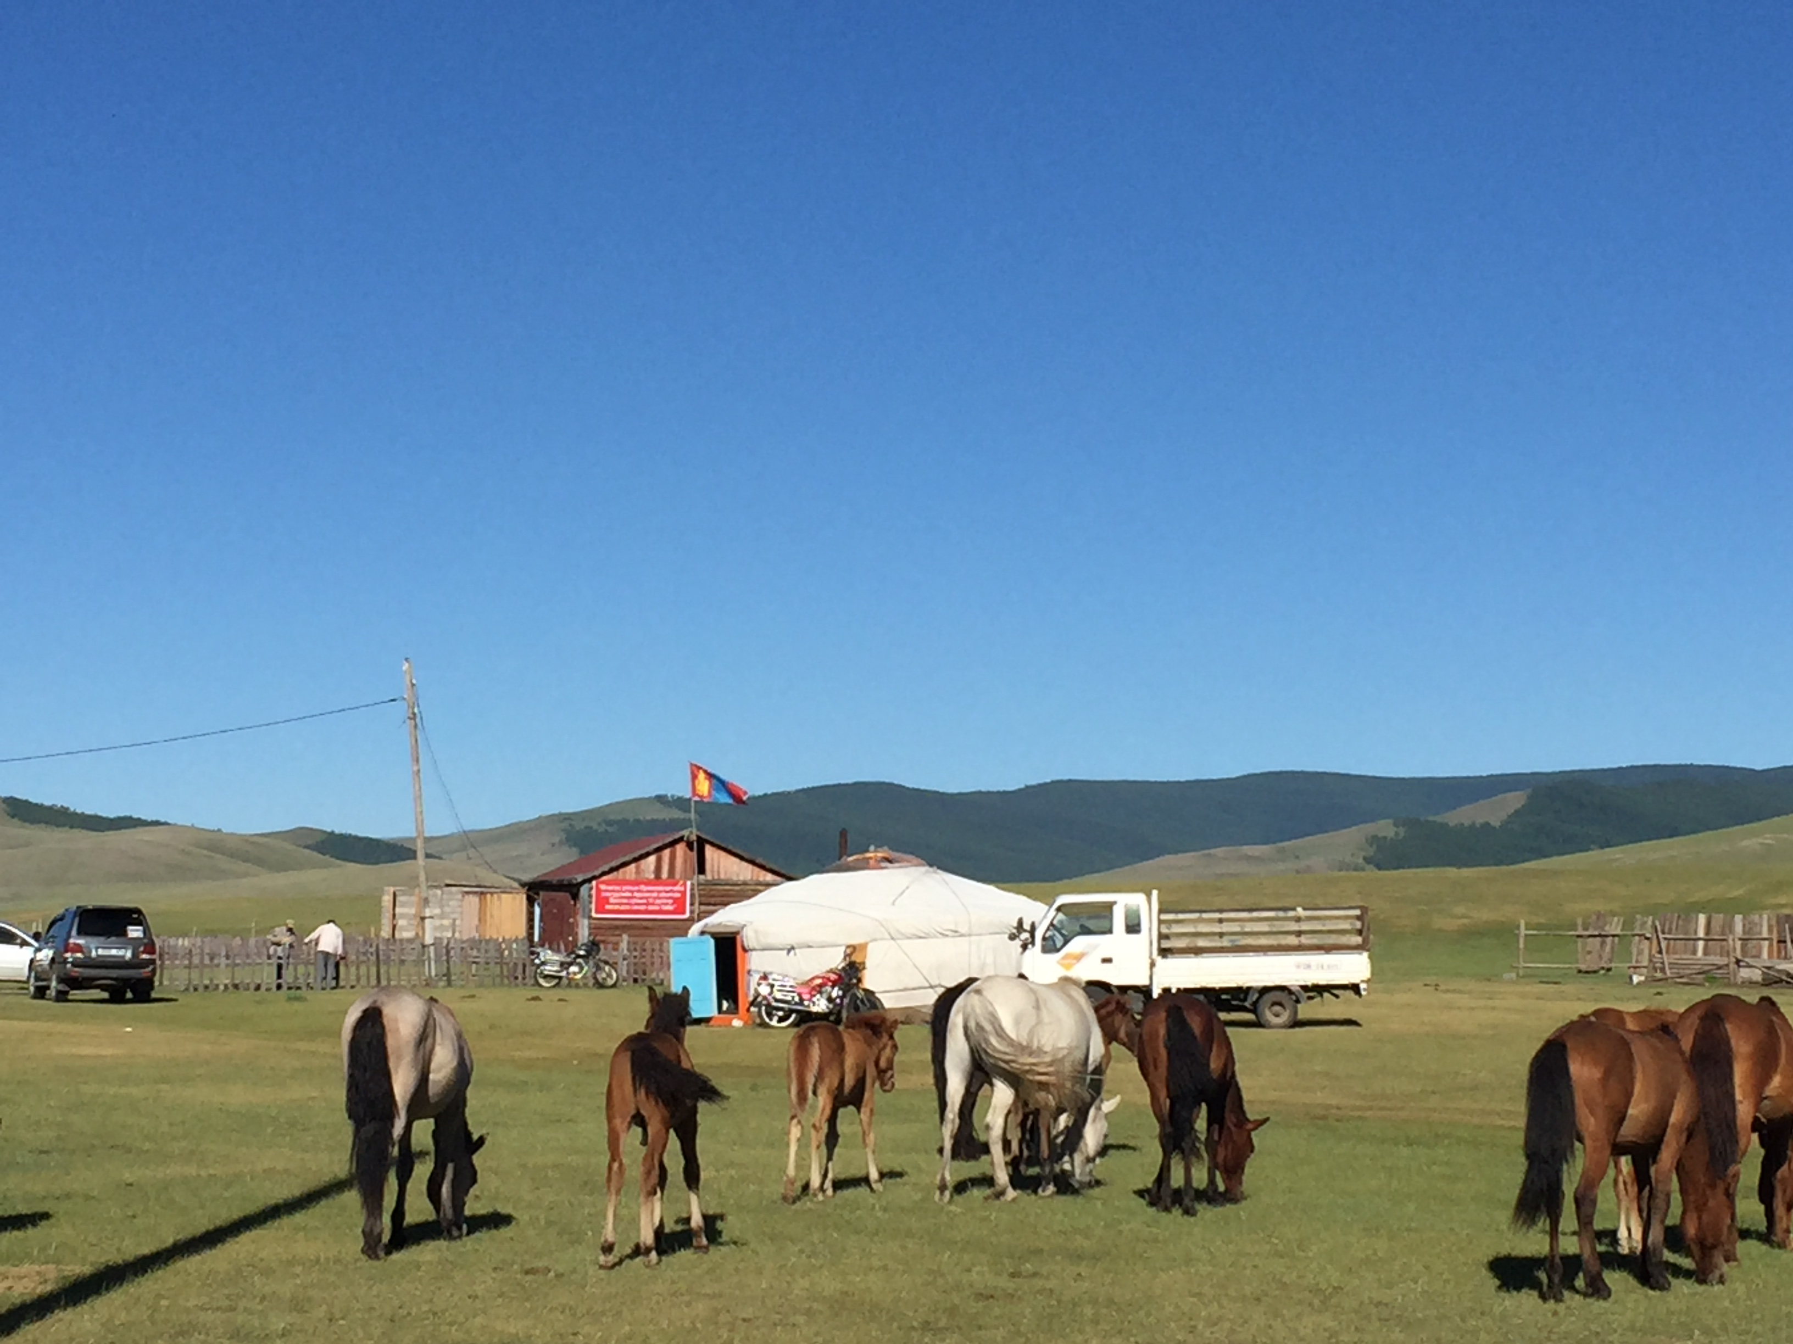

Outside, there’s a generator. Inside, on the basis of the voter’s thumb-print, a computer-based id checks the person’s name on the register, and the bigger stations immediately display the latest turn-out figures: a total plus a breakdown by age and gender. The voter collects a ballot paper like the simplified version shown in Table I, proceeds to a polling booth to make a mark by filling in one of the three ballparks, and then feeds the ballot into the electronic counting machine.

Table I The ballot paper

Candidates | Your vote
Battulga | O
Enkhbold | O
Ganbaatar | O

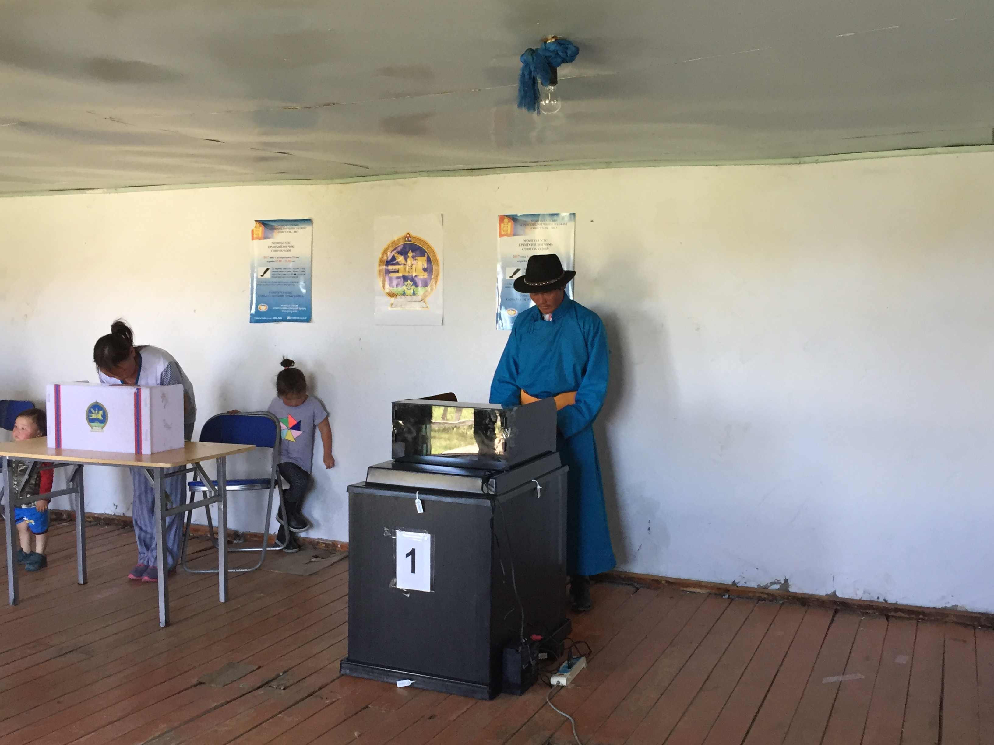

At the end of the day, zap: the overall totals along with the results for each candidate are zoomed to Ulaanbaatar and, shortly afterwards, Mongolia has a provisional result.

Well, that’s the theory. Sometimes, there’s no connection, and in at least one instance, the machine had to be dismantled from its ballot box, loaded onto a truck along with the generator, and then, at midnight from a nearby mountain top, a modem connection was established and the results were zapped from there. Just in case, in half of the polling stations, a manual count confirmed the technology.

* * * * *

What a brilliant arrangement. Yet inside this beautiful bottle, there’s no airag – the Mongolian alcohol made from milk. Admittedly, it’s not the sour first-past-the-post, fptp, as in the uk and usa, but that which is only slightly less bitter, the two-round system, trs, à la France.

So the winner is the candidate who gets an absolute majority in the first round or a simple majority in the second. But “all votes cast” – to quote the electoral law – means not only the votes cast for the candidates but also any blank votes, which are definitely regarded as valid, and even, perhaps, any invalid votes as well. In a word, there was much confusion.

The first round results were Battulga 38.6%, Enkhbold 30.8 and Ganbaatar 30.6, a mere 2,000 votes separating the last two. If the latter totals had been the other way round, who knows what the outcome of a second round between Battulga and Ganbaatar might have been? trs can be capricious. In addition, nearly 20,000 votes were blank. Ganbaatar was bound to react…

* * * * *

Out on the steppes, the herders move ger up to four times a year, always in search of pastures for their huge flocks. In the summer, they’re in the mountains; in winter, down on the plains. There are few fences or concepts of individual land ownership; nevertheless, all recognize that this bit ‘belongs’ to this extended family, and that area to that one. Likewise, in many small towns, everyone knows everyone else and, while individual houses are usually separated from their neighbours’ equally simple abodes by a wooden fence, there is still a sense of communal living.

Mongolia’s electoral law reflects this: it is designed to be fair. There were three candidates, so the three expenditures were limited, as were advertising spaces in the media. The trio shared billboard spaces on the main street for a restricted number of posters. Each was allowed only so many campaigners, some of whom were tasked with keeping an eye on the work of the other parties’ activists. As part of the campaign, they congregated in certain designated locations, three decorated gers alongside each other, all campaigning in a nice quiet way, not so much knocking on doors, rather waiting for the voters to knock on theirs. It was all, in theory, very fair. Sure enough, there were to be winners and losers but, as in a Naadam wrestling match, (a Naadam is the national summer sports festival), the losers don’t get hurt. Furthermore, especially in those villages and towns where the parties are equally divided on the local council, such fairness prevails, and parties often practice a form of power-sharing, the local governor from one party, the head of the council from another.

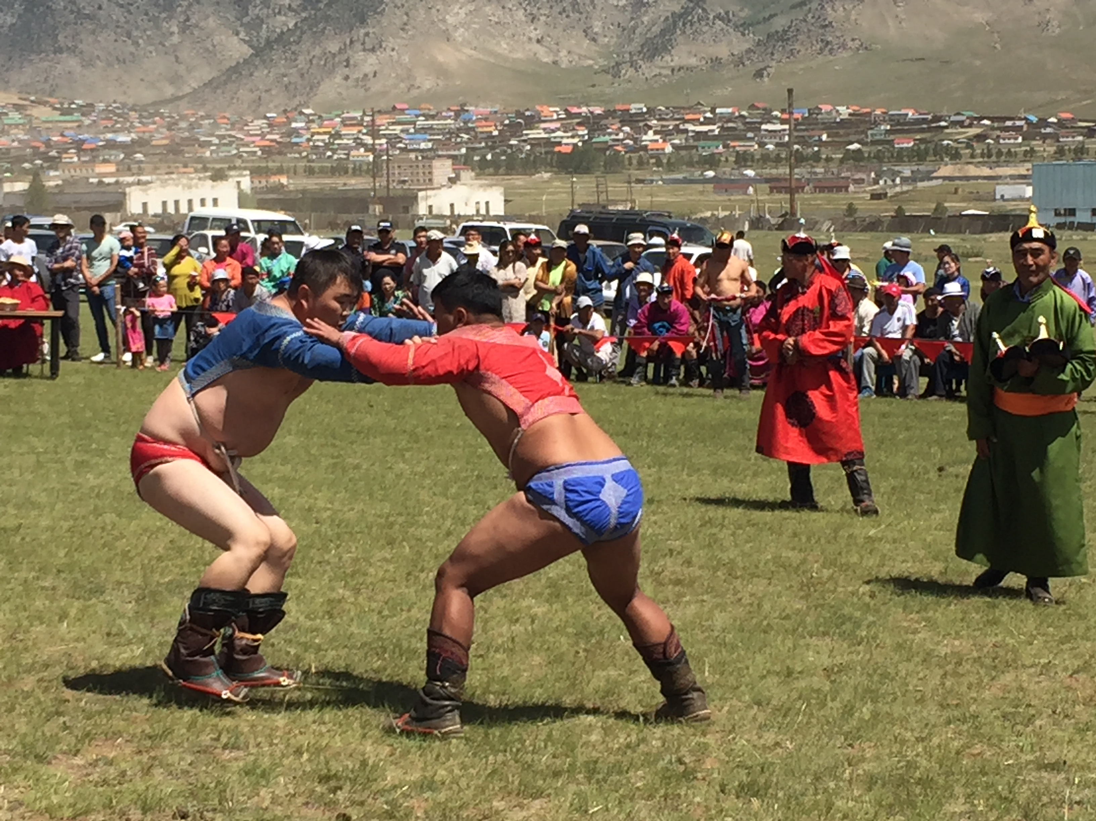

trs, however, is factional and divisive. So parties are tempted to deploy black propaganda and other negative tactics to try and increase their vote. Indeed, the most recent election was marred by quite a few accusations of malpractice, albeit at a fairly insignificant level… out on the steppes. In the capital, in contrast, adversarial politics was at its height with allegations of huge bribes, massive off-shore accounts and other forms of large-scale corruption.

Now the electoral law says that the top two candidates from the first round go into the majority vote final. But, as noted, blank votes are counted as valid. And Ganbattar did indeed react: he encouraged his supporters to vote blank, so to turn the second round into a sort of re-run of the first, and there was therefore the possibility that neither Battulga nor Enkhbold would get a majority – as in a 49% and 48% and 3% result. In fact, the outcome was 50.6%, 41.2% and 8.2% – a five-fold increase in the blank vote. Phew: in a word, Mongolia was lucky, and by a whisker, a further election was avoided.

* * * * *

A single-round voting system in which the voters could cast a 2nd preference as well as their 1st could have been more suitable. In a limited alternative vote, av, for example, if none of the three candidates received 50%+ of the votes, the candidate with the smallest number would be eliminated and his votes would be transferred in accordance with the voters’ 2nd preferences. On the basis of the subsequent revised totals, the leading candidate would then be declared elected. The appropriate ballot paper would be similar to that shown in Table II.

Table II An av ballot paper

Candidates | 1st preference | 2nd preference
Battulga | O | O
Enkhbold | O | O
Ganbaatar | O | O

The advantages would be several. The first one is huge: because success might depend not only on the sum of 1st preferences received, but also perhaps on the 2nd preferences, the parties would be incentivised to seek the 2nd preference support of those whose 1st preferences laid elsewhere. Secondly, of course, there would be only one round of voting. Thirdly, a result would be guaranteed. And fourthly, there would be a huge saving in time and money spent, so such a one-round system would certainly be the greener option.

The disadvantages to this proposal are also several. It would require rather more complex voter education efforts; there again, from Ireland to Papua New Guinea, voters have invariably managed to use a preferential voting system. In addition, while the electronic count would not present any great difficulties to the computer programmer, the manual recounts would be more complex for only the first stage could be conducted in the polling stations.

More importantly perhaps, like trs, av can also be capricious. Consider the following voters’ profile, in which nine voters cast their 1st and 2nd preferences for the three candidates, A, B and C, as shown in Table III.

Table III A Voters’ Profile

Preferences | Number of Voters
 | 2 | 3 | 4
1st preference | A | B | C
2nd preference | B | A | A

In fptp, (fake post-truth polling), the winner would be C with a score of 4. In trs, B and C would go through to the second round so, if the voters’ preferences remained unchanged, the outcome would be B with 5 to C’s total of 4. While in av, the least popular candidate in the first round, A, would be eliminated and its votes transferred in accordance with its two voters’ 2nd preferences, so the outcome would be a win for B, again with 5 to C’s 4.

* * * * *

In the above voters’ profile, even a cursory glance would suggest that, in fact, the most popular candidate is A, the 1st preference of only two voters but the 2nd preference of all the other seven. So maybe the more robust electoral system would be a Borda count, bc, in which the ballot paper would be similar to that shown in Table II. In such a three-candidate/two-preference contest, a 1st preference would get 2 points while a 2nd preference would get 1; so the outcome would be A 11 points, B 8 points and C 8 points, so the winner would indeed be A.

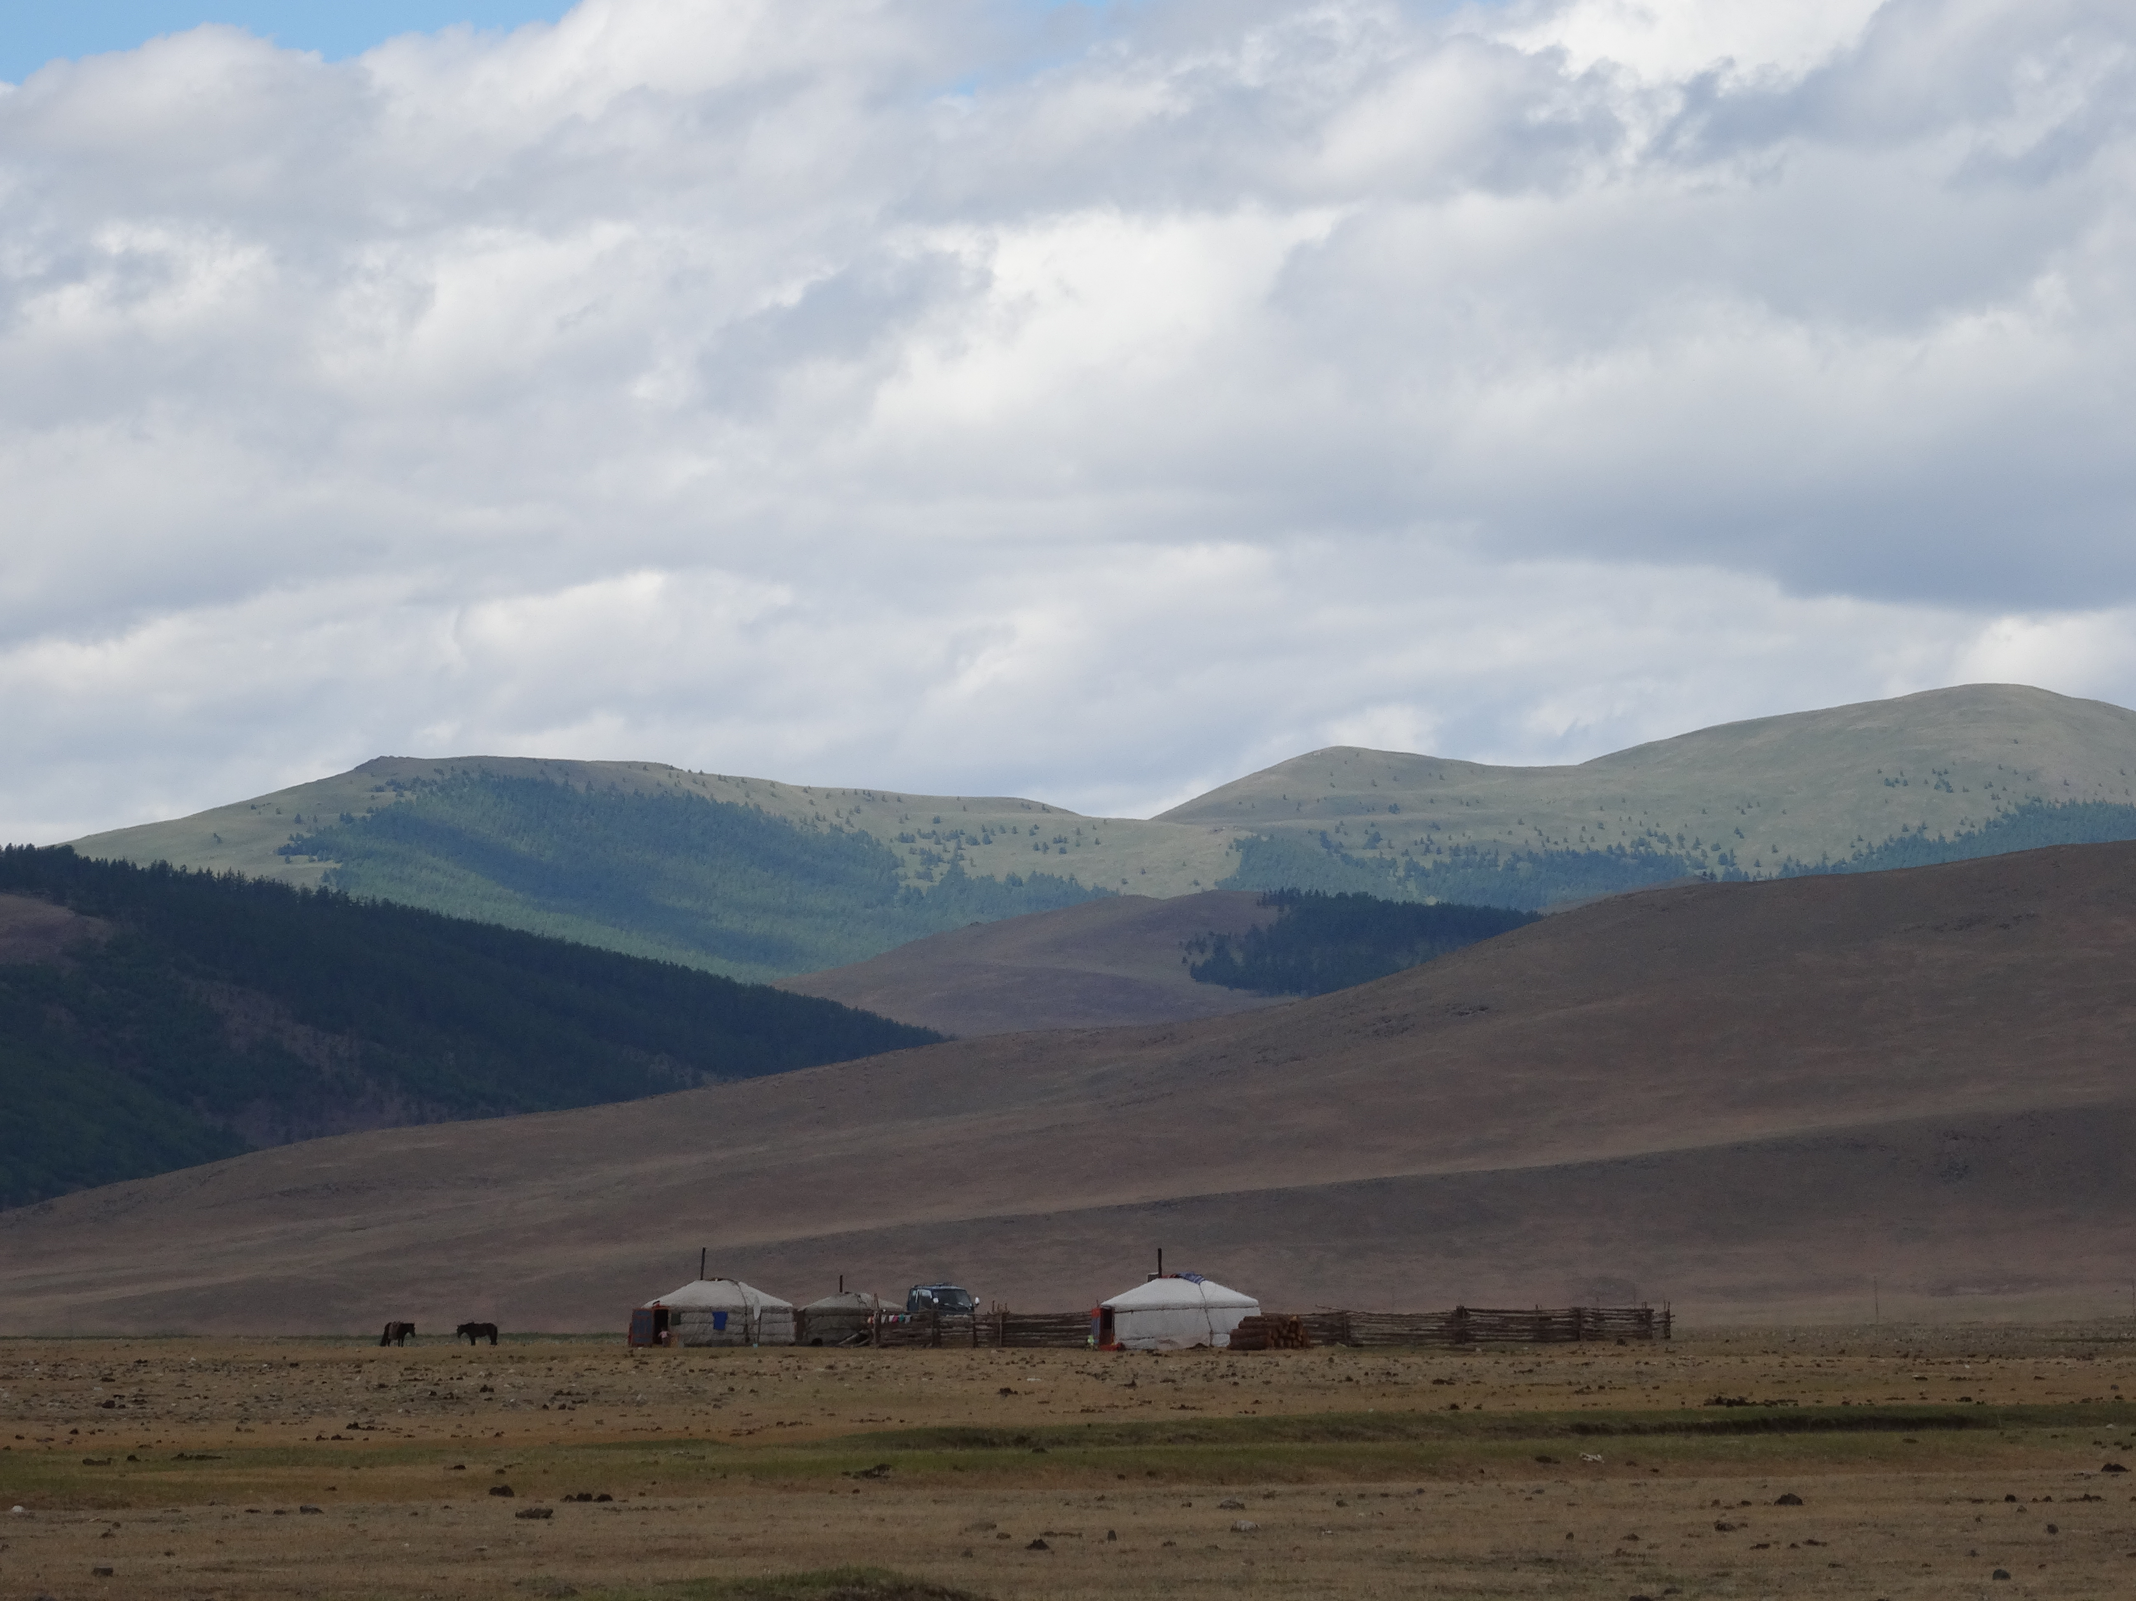

With a bc, voter education would be easier, and secondly, any manual recounts could be conducted in their entirety in the polling stations. Furthermore, the bc is inclusive, it is non-majoritarian; indeed, at best, the winner is the candidate who gets the highest average preference – and an average, of course, involves every voter, and not just a majority of them. On balance, then, it is suggested that the more appropriate electoral system would be a bc.

Peter Emerson
The de Borda Institute
www.deborda.org
Belfast
19.7.2017

